Information Transfer Policy
Version: V2.1
Review Date : 23/11/2023
Security: Intragen Internal
ITSEC-111

1 Purpose, Scope and Users
The purpose of this document is to ensure the security of information and software when they are exchanged within or outside the organisation.
This document is applied to the entire ISMS scope, i.e. to all the information and communication technology and information within the scope.
Users of this document are employees of Intragen.

2 Reference Documents
- ISO/IEC 27001 standard, clauses A.13.2.1 and A.13.2.3
- Information Security Policy

3 Transfer of Information

3.1 Electronic Communication Channels
The organization's information may be exchanged through the following electronic communication channels: Non-sensitive company data through all company systems, such as e-mail, teams, SharePoint. Sensitive information needs a different approach. First of all, employees need to thoroughly considerate if there are no other options than transferring the sensitive data. Furthermore, if there is no other option, the data should be transferred with a data transfer system that is approved by the Security Officer or an equivalent employee from IT.
CTO determines the communication channel that may be used for each type of information, and possible restrictions regarding permissions to use the communication channels, i.e., defines which activities are forbidden.
In addition to rules set by the classification, ISMS Manager prescribes additional controls for each type of data and communication channel, based on risk assessment results.

3.2 Relations with External Parties
External parties include various service providers, companies for hardware and software maintenance, companies handling transactions or data processing, clients, etc.
Before exchanging information and/or software with any external party, an agreement must be signed, which is the responsibility of CTO. The agreement can be a separate document or part of an overall commercial agreement with the external party (e.g. general terms and conditions), may be in paper or electronic for and must contain clauses in line with the risk assessment, including at least the following:
- method of identification of the other party
- authorisations to access information
- ensuring non-repudiation
- technical standard for data transfer
- incident response
- labelling and handling sensitive information
- copyright
Agreements with external parties must be drawn up according to the Supplier Security Policy.

4 Managing Records Kept on the Basis of this Document
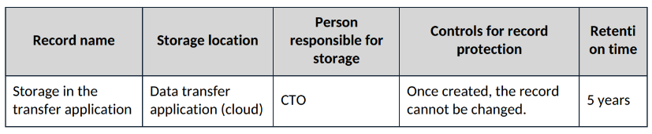

5 Document Management
The owner of this document is the ISMS Manager, who must check and, if necessary, update the document at least every 12 months.

